**“Dynamic Compensation-Impedance Matching Networks for Optimal Power Transfer Efficiency in Single-Coupling Capacitor Wireless Power Transfer (SCC-WPT) Using Software Defined Networking (SDN)”**

ENGR 8220 Research Project Proposal

Prof. Billy Kihei

Upon following the schedule in the proposal:

1. **ANSYS** 
   1. **Learn ANSYS software.**

**(75% completed (**

I am working well; I am still figuring out how to interface ANSYS with MATLAB to send the information from the receiving plate to the transmitter plate to decide which compensation configuration is used to maximize the transfer power and compensate for the change in coupling capacitance.

Receive Cc amplitude.

Channel

Send the Cc value to transmitter.

Determine the compensation circuit.

Determine the compensation parameter.

**MATLAB**

**ANSYS (ELECTRONIC DESKTOP)**

Send the information of coupling capacitance to transmitter circuit

Create the model

?

Determine the compensation circuit parameter

Changing the distance between the plates

Calculate the power transfer and efficiency

Calculate the coupling capacitance

* 1. **Create the first project for capacitor.**

**(100% completed)**

I have developed a test project for the coupling capacitor and show the effect of changing the distance between the plates on the coupling capacitance value as shown:

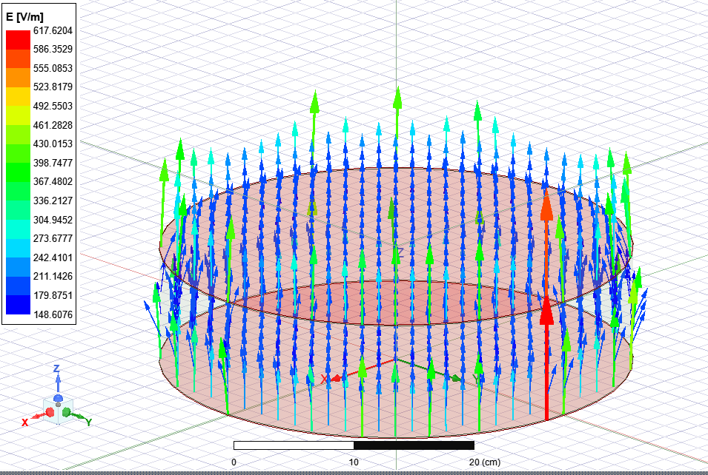

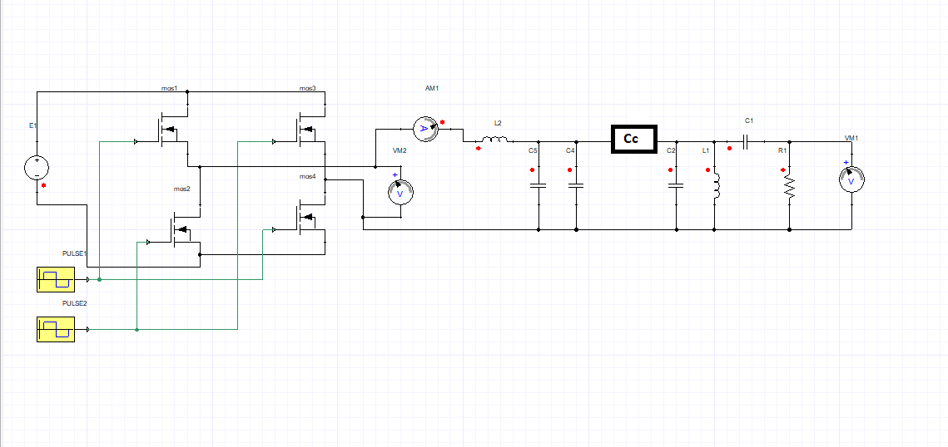

* 1. **Debug the first simulation and make a proposal.**

**(100% completed)**

At this point, the proposal was submitted. The simulation was ready but still needed to connect the result from ANSYS electronic desktop to MATLAB in order to send the information to the transmitter side and make an array for compensation to select the compensation ( SS, SP, PS, PP) (S= series, P= parallel) that maximize the transfer power and enhance the overall efficiency.

**SDR**

**2.1. Learn about SDR in WPT**

**(40% completed)**

Until now, I’ve been trying to know how we can use the SDR in MATLAB using YouTube videos, but still, there is some problem:

**Performance limitations:** SDR applications require real-time processing of large amounts of data (we need this data, and I am searching to get data about the changing distance and the maximum distance that can be used).

**The complexity of SDR algorithms:** designing and implementing the necessary algorithms requires expertise in signal processing and communications theory, and I’m trying to understand this point.

**2.2. How we can insert SDR in the simulation**

**(30% completed)**

I found out the location of each sender and receiver in our system and how to connect them, but due to the lack of available data, I am having difficulty examining the system. However, I tested each part of the system and ensured it could take the data and work without any problems.

**2.3. Test the project.**

**(10% completed)**

I need to know how to connect each part of the system with another part without delay and how to connect ANSYS to MATLAB.

**3. simulation**

**Debug Simulation**

**(50% completed)**

I made a test for each part of the system, and the result showed that

1- ANSYS electronic desktop gives me a precise value for the coupling capacitor, and when the distance between the plate becomes more extensive, the value of the capacitance decreases significantly, and this is true because the relation of the capacitance and the distance is c=ep A/D.

2- the inverter was built using MATLAB software and ANSYS, and both gave the same result for converting the DC input voltage (60v ) to AC voltage with 6.78 MHZ.

3- the compensation circuit is first tested as LCC compensation and then tested to determine the difference between other configurations.

4- The information was sent from the receiving plate to the transmitter plate, and the process was tested to show how we can use this part in the project.

5- At this point, the multi-load is not tested.

**\*Updates to proposal Expectations:**

**Multi-Load WPT Using Single Coupling Capacitance**

**(0% completed)**

After applying the simulation for one receiver, I decided to extend the work to cover multi-load simultaneously with a single transmitter plate and multi-receiving plates and how this plate can increase the mutual capacitance in the system. Moreover, how can we make this in a single compensation circuit?

**Summery**

In this project, until now, I have tested all the parts with results that are very close to the expected results, but there still needs to be an obstacle represented by how to integrate the parts from different software.

**Completed Work:**

Create first project for capacitor

Debug first simulation and make proposal

**In-progress**

Learn ANSYS software

Learn about SDR in WPT

How we can insert SDR in the simulation

Test the project

Debug Simulation

**Not Started**

Updates (**Multi-Load WPT Using Single Coupling Capacitance)**

|  |  |  |  |  |  |  |  |  |  |  |  |  |  |  |
| --- | --- | --- | --- | --- | --- | --- | --- | --- | --- | --- | --- | --- | --- | --- |
|  |  | **Mar** | | | | **Apr** | | | | **May** | | | |  |
|  |  | **1-29** | | | | **3-26** | | | | **1-3** | | | |  |
| 1 | **ANSYS** |  |  |  |  |  |  |  |  |  |  |  |  |  |
| 1.1 | Learn ANSYS software | 75 % | |  |  |  |  |  |  |  |  |  |  |  |
| 1.2 | Create first project for capacitor |  | completed | |  |  |  |  |  |  |  |  |  |  |
| 1.3 | Debug first simulation and make proposal |  |  | Completed | |  |  |  |  |  |  |  |  |  |
| 2 | **SDR** |  |  |  |  |  |  |  |  |  |  |  |  |  |
| 2.1 | Learn about SDR in WPT |  |  |  |  | 40% | |  |  |  |  |  |  |  |
| 2.2 | How we can insert SDR in the simulation |  |  |  |  |  | 30% | |  |  |  |  |  |  |
| 2.3 | Test the project |  |  |  |  |  |  | 10% | |  |  |  |  |  |
| 3 | **Simulation** |  |  |  |  |  |  |  |  |  |  |  |  |  |
|  | Debug Simulation |  |  |  |  |  |  |  | 50% | |  |  |  |  |
| 4 | **Deliverables** |  |  |  |  |  |  |  |  |  | 41.5% | |  |  |
| 5 | **Updates** |  |  |  |  |  |  |  |  |  | 0% | |  |  |
|  |  | Simulation for capacitance completed | Proposal completed |  |  | Milestone 3 submitted |  |  |  |  |  |  |  |  |